Do you want help with FOOD AND MOOD?

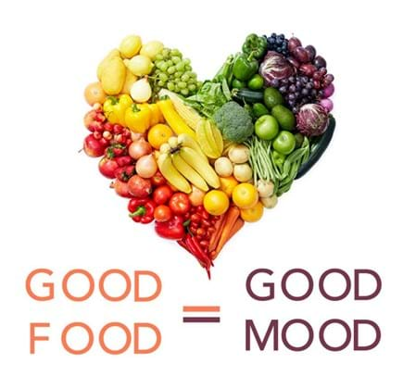
Group Sessions with Evie Day (Health and Wellbeing Coach):
- To understand what impacts your eating and your mood

- To work on changing your behaviour to feel better

- To talk and share ideas

2026 drop-in sessions at Shirehampton Group Practice, in the Health Education Room (at the end of reception):

13:00-14:30 Thursday 8th January
15:30-17:00 Thursday 22nd January
13:00-14:30 Thursday 5th February
15:30-17:00 Thursday 19th February
(Please note session times alternate bi-weekly)

This is not clinical – Evie is not a doctor or psychiatrist:
- You will not be medically assessed
- You will not be prescribed medicine

